ADMINISTRATOR’S USER GUIDE
Version: 00-01

Contents
1 Introduction 2
2 Administrator Login 2
3 Administrator Control Page 3
4 Create/Manage Sub-Categories 4
4.1 Create A Sub-Category 4
4.2 Sub-Category Management 5
4.2.1 Modify Sub-Categories information 5
4.2.2 Delete a sub-category 6
5 Create/Manage Venues 7
5.1 Create a venue 7
5.2 Venue Management 10
5.2.1 Modify Venue’s Information 11
5.2.2 Delete a Venue 13
6 Create/Manage Events 14
6.1 Create an Event 14
6.2 Manage Events 16
6.2.1 Modify an event 16
6.2.2 Deactivate an event 18
7 Create/Manage Payment Method 19
7.1 Create Payment method 19
7.2 Manage Payment Type 19
7.2.1 Modify the Payment Type 20
7.2.2 Delete Payment method 20

Introduction
Go Events is an online ticket sale system. It offers a variety of tickets based on three main event categories: concerts, sports, and movies. Each category contains sub-categories to filter the need of customers who are looking for a particular event. The ADMINISTRATOR’s USER GUIDE mainly concerns with assisting the Administrator to create sub-categories, events, payment types and venues. This manual includes descriptions, graphics, step-by-step procedures and all essential information for the administrator to access and make full use of the system.

Administrator Login
Instructions to log in as an administrator

- Click Login/Register on the upper right corner above the navigation bar to go to the Login/Registration page.
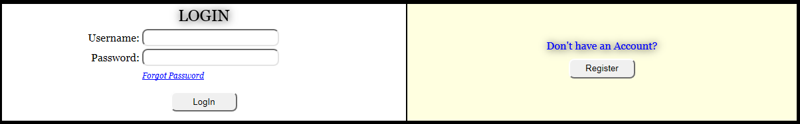

- Fill in username and password.

Note:
- Use the Default password that Go Events provides to login as an administrator.
  - Username: Admin
  - Password: admin

- Click Login button to log onto the administrator’s page.

Note:
- If one or more fields are empty and the Register button is clicked, the asterisk sign * will appear to indicate that all fields must be filled.
- If the Username or the Password is incorrect, the error message will appear to indicate that the user has entered incorrect username or password.

Administrator Control Page
Instructions to use the admin control page

Option 1 - Select the task want to work on by clicking on the link.

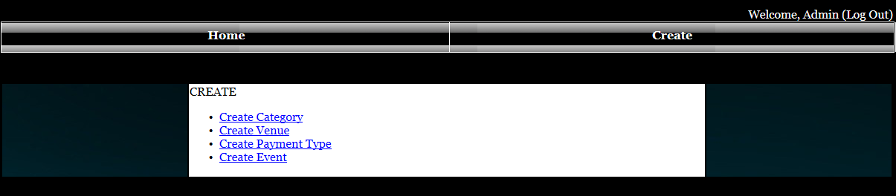

Option 2 - Hover the cursor over Create on the navigation bar to display all the tasks.

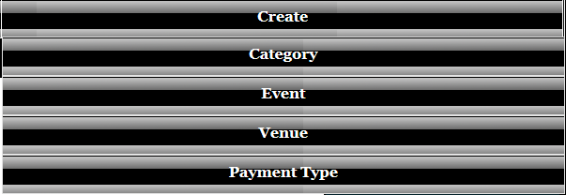

Create/Manage Sub-Categories

Create A Sub-Category
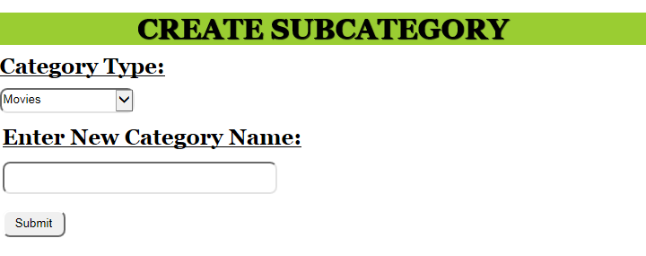

1. Select a category
2. Fill in a sub-category name
3. Click Submit button to create a new sub-category
Note:
- If one or more fields are empty and the Submit button is clicked, the asterisk sign * will appear to indicate that all fields must be filled.
- If a sub-category creates successfully, a message will appear to indicate that the sub-category has been created successfully.

Sub-Category Management

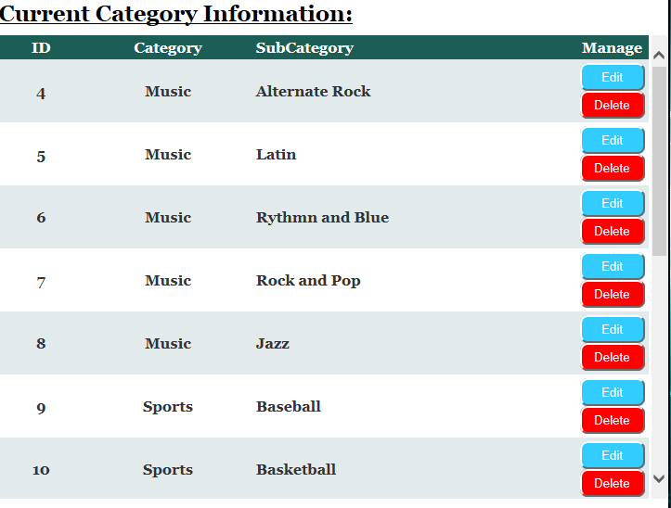

Modify Sub-Categories information
1. Click edit button if wish to modify sub-category information.
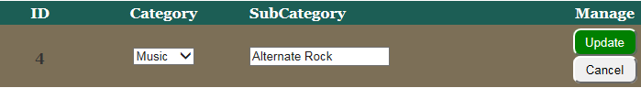
2. Select Category
3. Fill in Sub-Category name

4. Click Update button (A confirmation message box will appear)
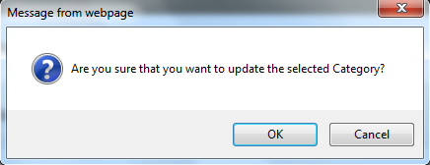

4a. Click OK to update the modified information
4b. Click Cancel to cancel the update.

Delete a sub-category
1. Click Delete button to delete a particular sub-category

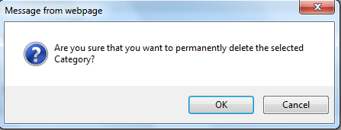
1a. Click OK to update the modified information
1b. Click Cancel to cancel the update.

Create/Manage Venues

Create a venue
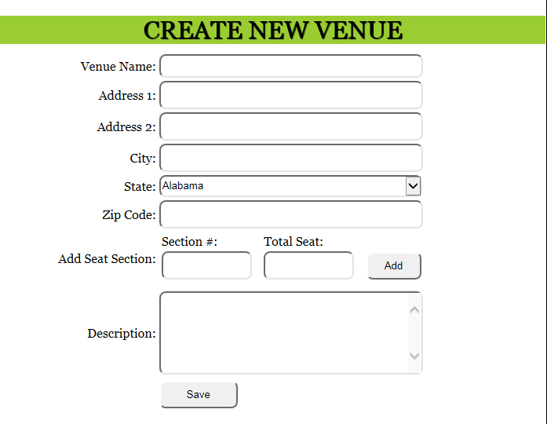

1. Fill in the followings:
  - Venue Name
  - Address 1
  - Address 2 (Optional)
  - City
  - State
  - Zip Code
  - Description (Optional)
2. Fill in the followings for Add Seat Section
a. Section #
b. Total Seat
3. Click Add to add the seat section and total seat to a temporary chart.
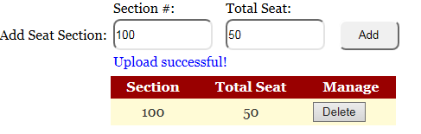

Note:
- If one or more fields are empty and the Add button is clicked, the asterisk sign * will appear to indicate that all fields must be filled.
- If the seat section and the total seat upload successfully, a message and a table will appear to indicate that seat section and total seat have been uploaded successfully.
- If the venue has more than one section, repeat step 3 with different section and the total seat.
- If the section is already existed, a message will appear to indicate that the user need to add another section.

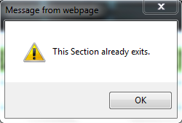

- If wish to delete the section and total seat, click Delete

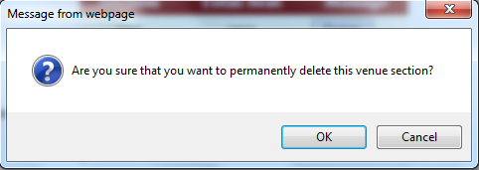

- Click OK to delate the seat section
- Click Cancel to cancel the deletion

4. Click Save button to save the venue to the database.

Note:
- A message will appear to indicate that the venue has been updated successfully.
- If one or more fields are empty and the Save button is click, the asterisk sign * will appear to indicate that all fields must be filled.

Venue Management
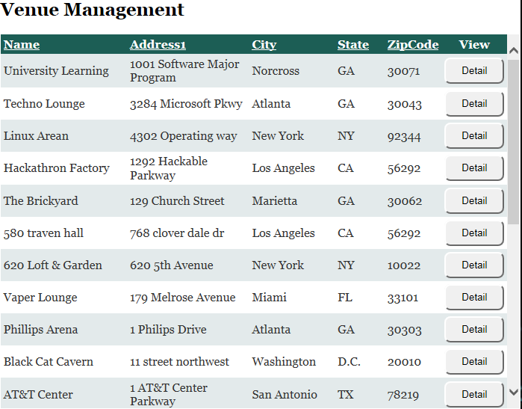

Modify Venue’s Information
1. Click Detail button if wish to modify a particular Venue
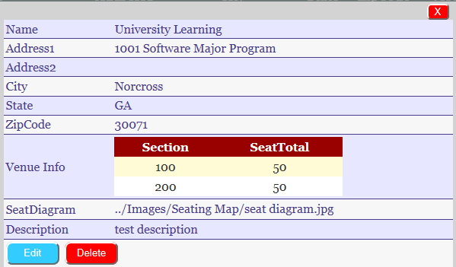

2. Click Edit button at the bottom to modify the Venue’s information.
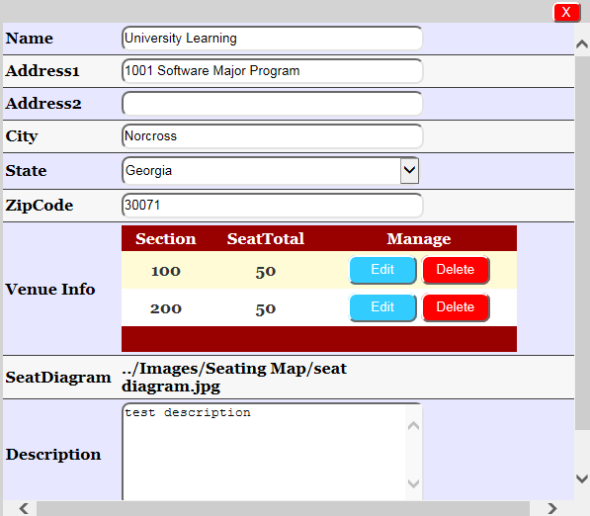

3. Fill out all the changes needed for the Venue
3a. Click Edit button on the Venue Info to modify Seat section and SeatTotal
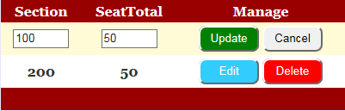
- Fill out the Section and SeatTotal
- Click Update button to update (A confirmation box will appear)
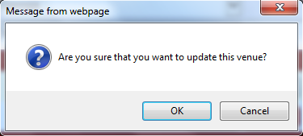
  - Click OK if wish to update the Seat Section and SeatTotal
  - Click Cancel to cancel the update.

3b. Click Delete button on the Venue Info to Delete the Seat section and SeatTotal.
4. Click Update button at the bottom to update the modified Venue’s information.

Delete a Venue

1. Click on the Detail button to view the Venue’s Detail
2. Click on Delete button if wish to delete a particular Venue (A confirmation message box will appear)
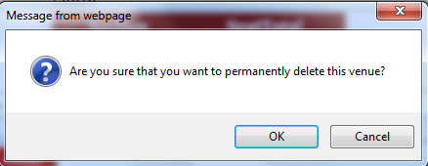
2a. Click OK to delete the venue.
2b. Click Cancel to cancel the deletion.

Create/Manage Events

Create an Event
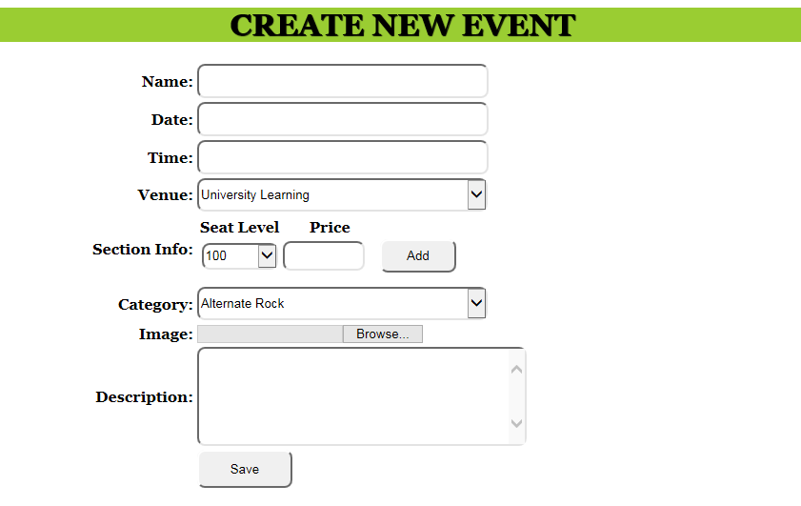

1. Fill out the followings:
- Name
- Date
- Time
- Select a Venue
- Select a Category
- Image
- Description (Optional)
2. Fill in the Price for the event
3. Click Add button to add the event’s price to a temporary chart.
Note:
- If the price is empty, a red asterisk * will appear to indicate that the price needs to be filled.
- If the price has successfully uploaded, a message and a temporary table will appear to indicate that the price has been uploaded successfully.

- If the venue has more than one sections, select the section, then add price.
- If the price for one section has already existed, a message will appear to let the user know that the section cannot have multiple prices.
- If the user enter some letters for the price, a message will appear to indicate that it is invalid price.

4. Click Browse button to open a Window Explorer to look for an image file
5. Click Save button to upload the event to the database.

Note:
- If one or more fields are empty and the Save button is clicked, the asterisk sign * will appear to indicate that all fields must be filled.
- If the date is in invalid format, a message will appear to indicate that the date has to be in the correct format (MM/DD/YYYY)
- If the time is in invalid format, a message will appear to indicate that the time has to be in the correct format (HH:MM:ss).
- If the event has been successfully updated, a successfully message will appear.

Manage Events
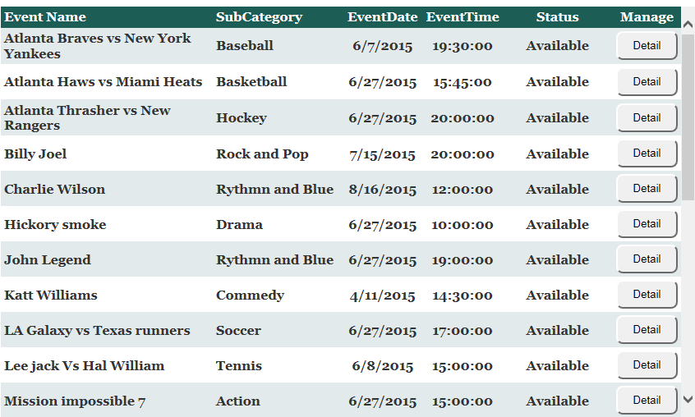

Modify an event
1. Click Detail button if wish to view a particular event in details
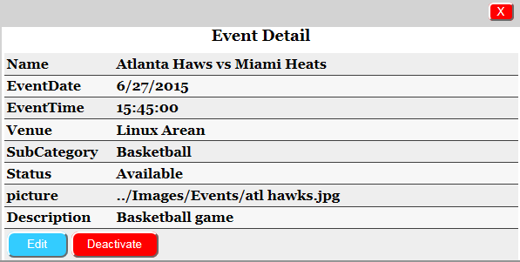

2. Click Edit if wish to modify Event’s information
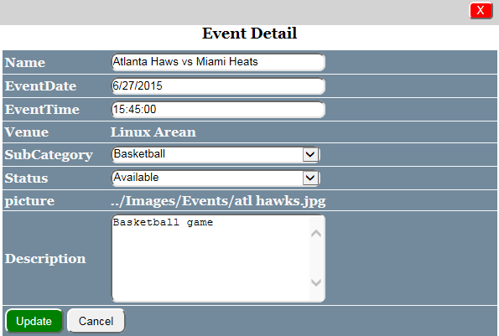

3. Fill out all the necessary changes for that particular event
4. Click Update to update the modified event
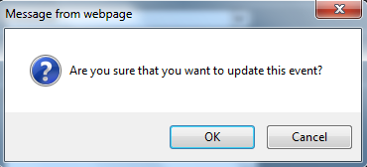
4a. Click OK to update the modified event
4b. Click Cancel to cancel the modified event

Deactivate an event
1. Click Detail button to view the Event details
2. Click Deactivate at the bottom of the table if wish to deactivate an event
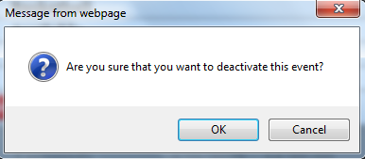
2a. Click OK to deactivate the event
2b. Click Cancel to cancel

Create/Manage Payment Method

Create Payment method
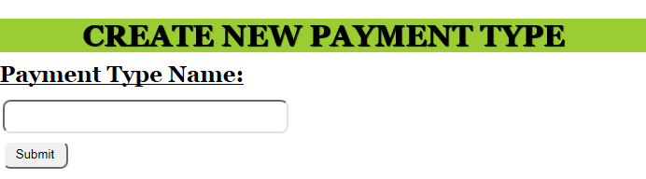

1. Fill out the payment type
2. Click Submit button
Note:
- If the payment type is empty and the Submit button is clicked, the red asterisk sign * will appear to indicate that the payment type must be filled.

Manage Payment Type
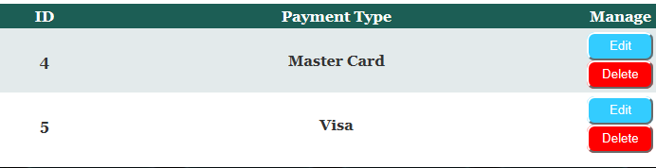

Modify the Payment Type
1. Click Edit if wish to modify the Payment type
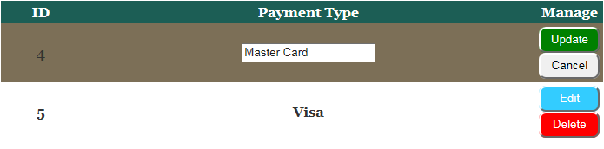
2. Fill in all the necessary changes
3. Click Update button to update the payment. (A confirmation message will appear)
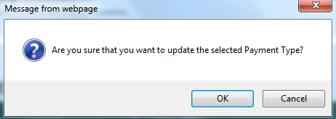

3a. Click OK to update the modified payment type
3b. Click Cancel to cancel the update.

Delete Payment method
1. Click Delete if wish to delete the payment method (A confirmation message will appear.)
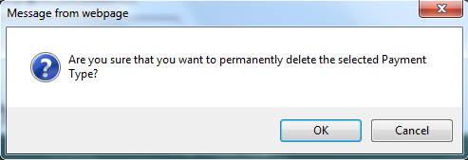

1a. Click OK button if wish to Delete the payment method
1b. Click Cancel button if wish to cancel the deletion.

